Lab 5 D23125496

1.) https://github.com/JakobReinshagen/Cloud-Computing/  
https://hub.docker.com/repository/docker/jakobreinshagen/cloudcomputing/general

2.) First create a Container registry:  
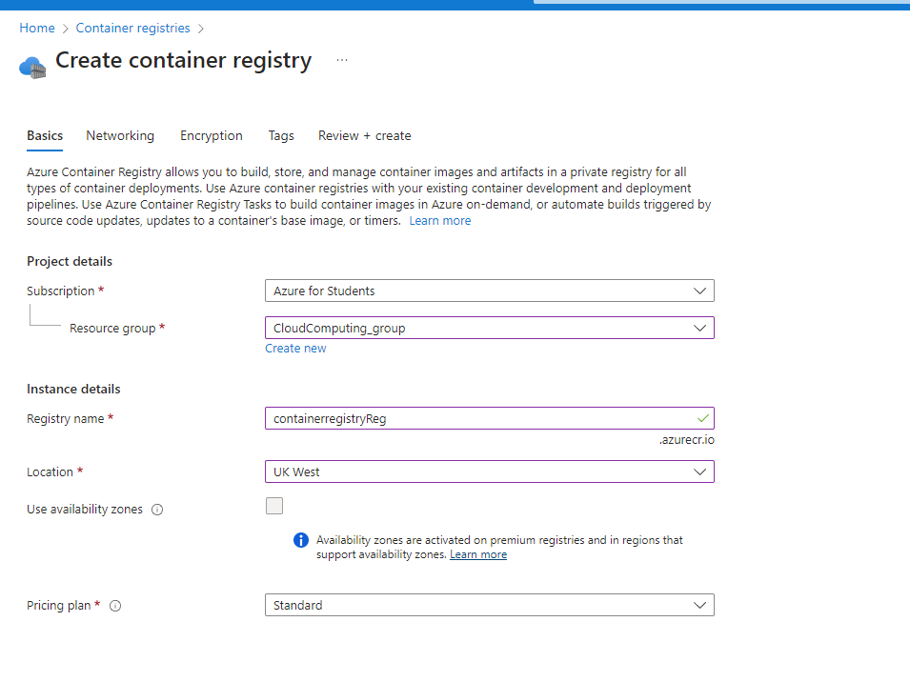  
Second create a kubernetes cluster service:  
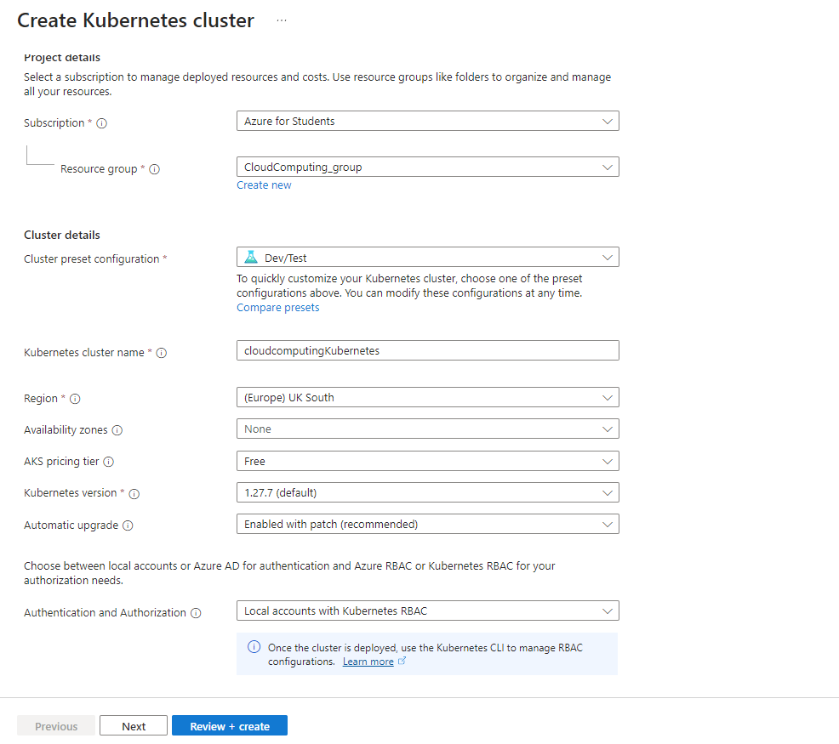  
After that I created a project on azure dev:  
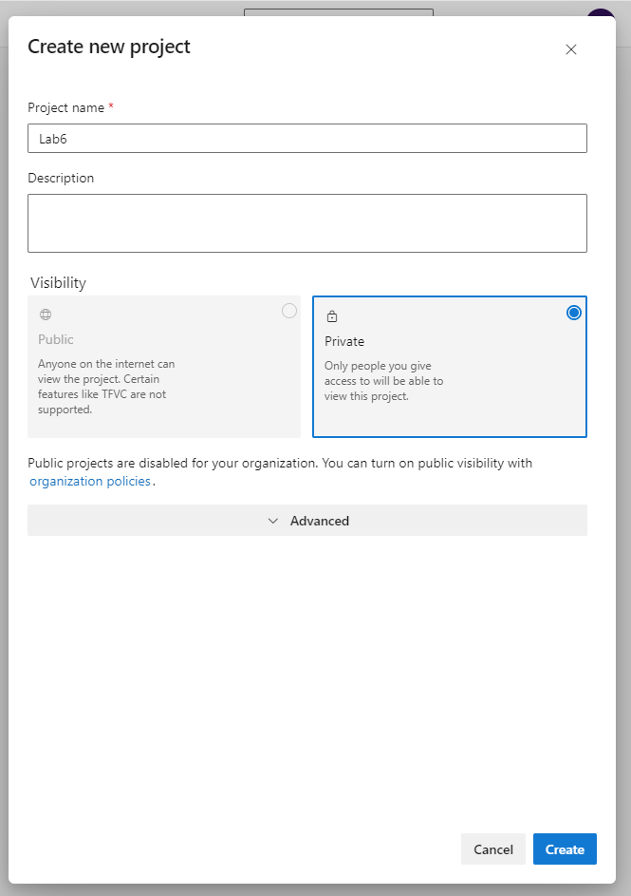  
  
After that you create a new pipeline there you select git as your source and select a kubernetes network:  
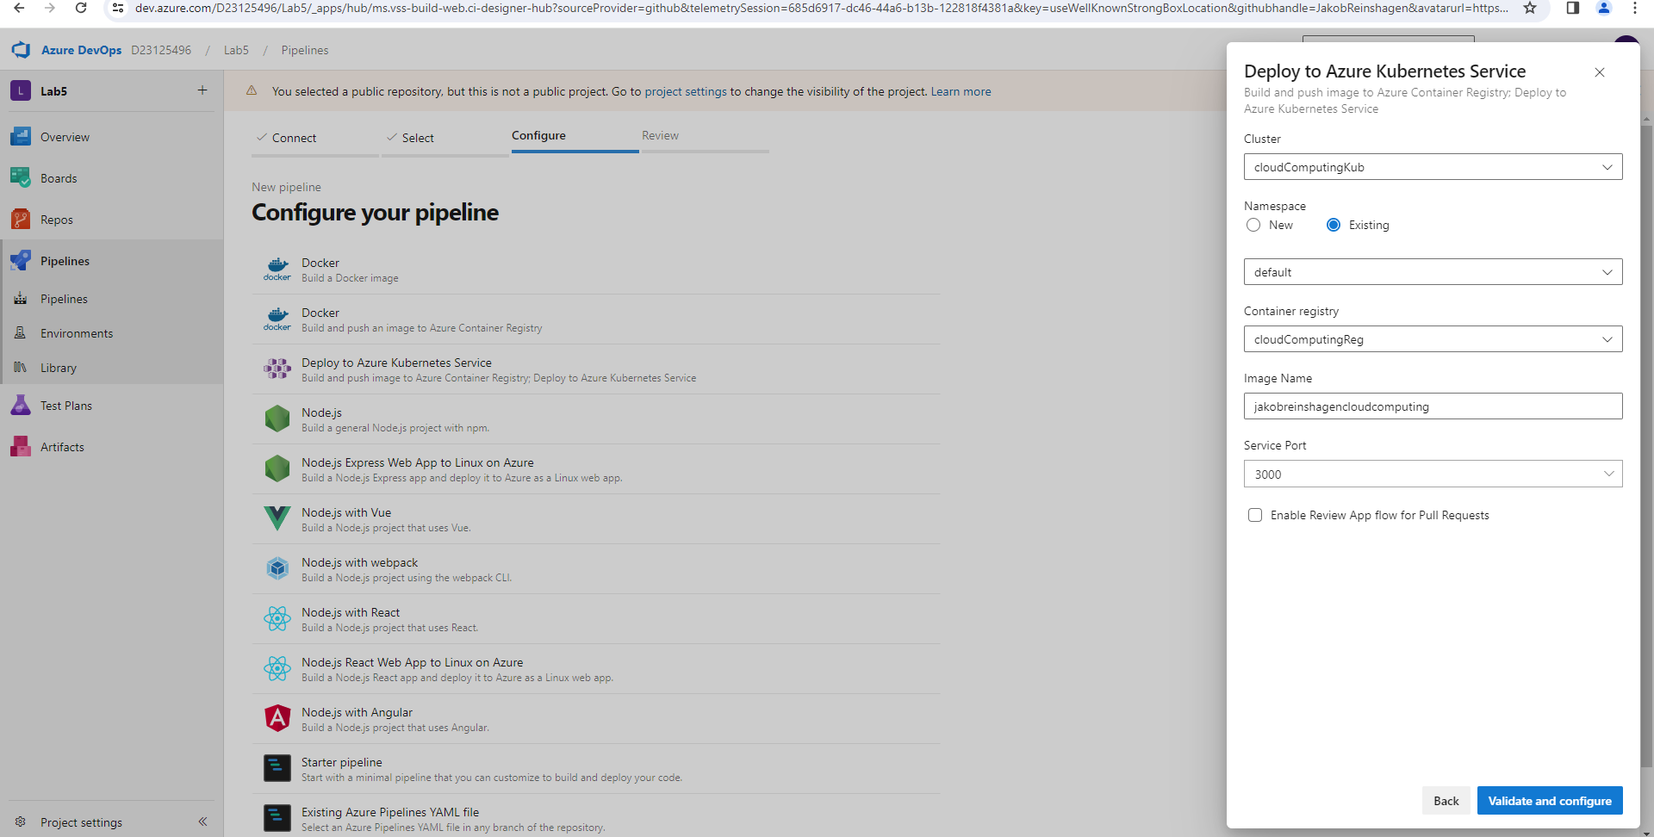  
After that you commit a file called azure-piplines.yaml to git. Now after every push in the main branch the pipeline rebuild itself automaticly and shows up on the kubernetes network.

3.) I in the app if you are finished, the item won’t be crossed out. The text is now crossed out with a cross.